1. Create a file and use `chmod` to set it to `rwx`.

Ans. 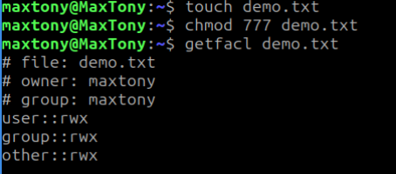

1. Create another file and change its owner using `chown`.

Ans.

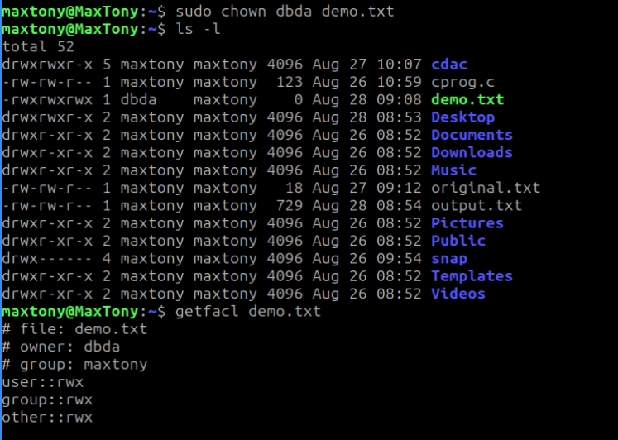

1. Create a group and assign file access using `chgrp`.

Ans.

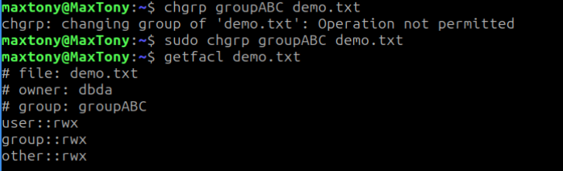

1. Open a file in `vi`, insert text, save, and quit.

Ans.

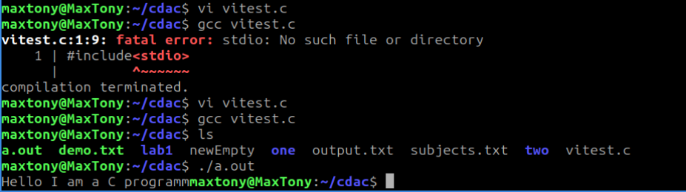

1. In `vi`, use find and replace to change a word in the file.

Ans.

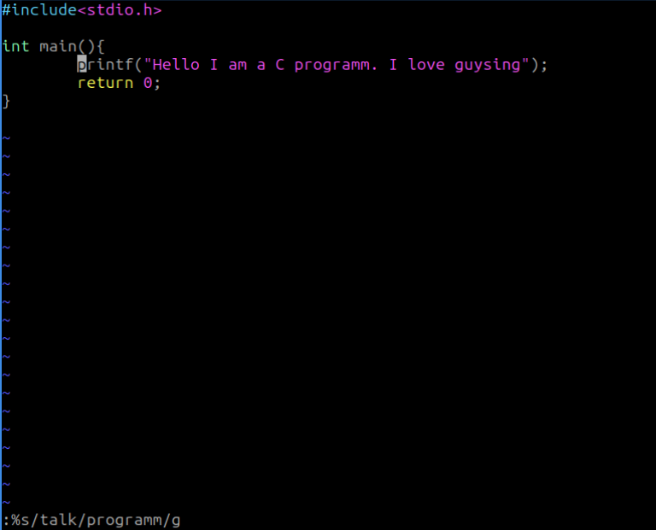

1. Write a shell script to print your name, roll number, and todayâ€™s date.

Ans.

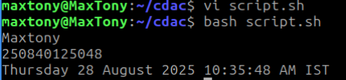

1. Write a shell script that accepts two numbers and prints their sum, difference, and product.

Ans.

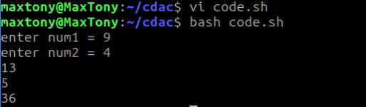

1. Write a script to check whether a file exists and is readable.

Ans.

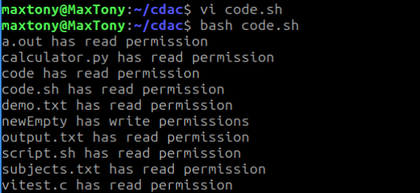

1. Write a script with a `for` loop to print numbers 1 to 15.

Ans.

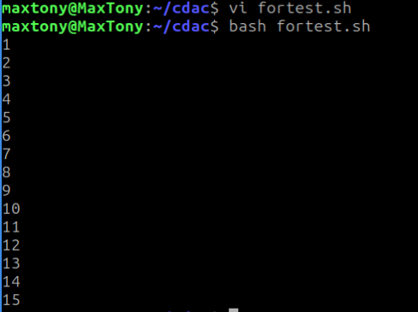

1. Write a script using `case` to check if a given character is a vowel or consonant.

Ans.